

**CSE 405: Computer Networks**

**Section: 02, Fall-2020**

|  |
| --- |
| A Project Report  on  **Design a full-fledged network for an organization with multiple subnets.** |
| Submitted By:  Name: Shekhor Chandra Saha  ID: 2017-3-60-025 |
| Submitted to:  Dr. Anisur Rahman  Associate Professor, Dept. of CSE |
| Date of Submission: 08-01-2021 |

**DEPARTMENT OF COMPUTER SCIENCE & ENGINEERING**

**EAST WEST UNIVERSITY**

**Introduction:**

Now a days, network design is very important. Basically, network is going to complex day by day. Now connections are mesh, bus and others topology. Because network design based on design and recommendations. Now a days, wireless communication is very popular and it is very used in last devices. Means Pc, Laptop, Mobile phone and other devices. By using wireless device, we don’t use to wire that’s why we can design the network smoothly in anywhere.

**Network Topology:**

Network topology means how a network is organized or designed. There are many types of network topology. Like: Bus, Mesh, Star and Ring. Now a days, Hybrid topology is very popular. Hybrid topology mainly combination of two or multiple topologies.

**IPv4 Structure:**

IPv4 address is a 32-bit address. For example 192.168.10.1. IP address is composed of two types of addresses:

1. Network address,
2. Host address and
3. IP address

Mainly IP component that determines which bits refer to the network and which bits refer to the host is called subnet mask.

**HTTP Server:**

HTTP server is used to host the webpages. Here we have imported our university webpages to the HTTP server.

**DNS Server:**

DNS server is used convert the domain name to equivalent IP address. For example: Url is [www.apollointernational.edu](http://www.apollointernational.edu) for this url we use an ip address which is a HTTP server. Web page Ip: 192.168.60.50. Mainly when we search then url or domain name then DNS convert it to a Ip address.

**DHCP Server:**

This server mainly helps use to give Ip address to connected computers or devices Automatically. We don’t need to insert Ip address one by one. It is very time consuming for build a design.

**Design and implementation:**

This is an University Area Network and it consists of router, switches and end devices. Here we use wireless connection to connect some end devices. Here all networks Ip address, Gateway Ip, DHCP server address, Web Server address, DNS Server address and all end device’s address are given.

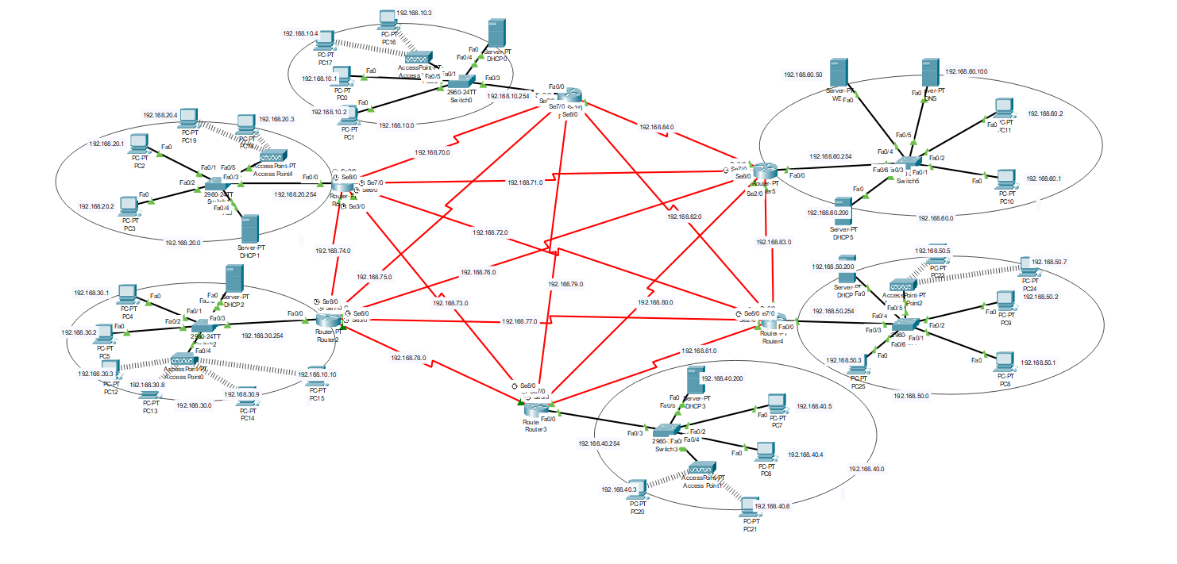

**Network Connection:**

I only give router 4’s network connection because all routers code are quite same. Here, Router 4’s code:

enable

config t

interface fa0/0

ip address 192.168.50.254 255.255.255.0

no shut

do wr

exit

interface se2/0

ipaddress 192.168.81.2 255.255.255.0

no shut

do wr

exit

interface se7/0

ipaddress 192.168.77.2 255.255.255.0

no shut

do wr

exit

interface se6/0

ipaddress 192.168.72.2 255.255.255.0

no shut

do wr

exit

interface se8/0

ipaddress 192.168.82.1 255.255.255.0

clock rate 64000

no shut

do wr

exit

interface se3/0

ipaddress 192.168.83.1 255.255.255.0

clock rate 64000

no shut

do wr

exit

**Routing Tabe:**

I only give router 4’s routing table because all routing table code are quite same. Here, routing table’s code:

enable

config t

router ospf 5

network 192.168.50.0 0.0.0.255 are 1

network 192.168.81.0 0.0.0.255 are 1

network 192.168.77.0 0.0.0.255 are 1

network 192.168.72.0 0.0.0.255 are 1

network 192.168.82.0 0.0.0.255 are 1

network 192.168.83.0 0.0.0.255 are 1

exit

**Ping Test:**

Use this Ping command for check the Network connectivity and communication.

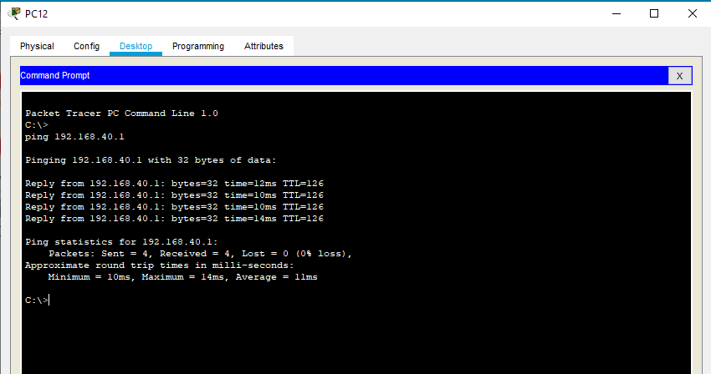

**PDU:**

We can also add sample PDU to understand whether a networks pc is communicating with other networks pc:

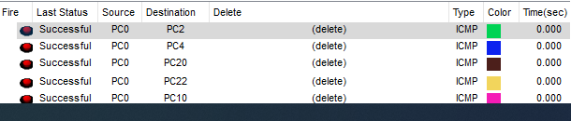

**Limitation:**

There are too many limitations. First of all, this network is too small so we can not use it. In real life network is more and more complex.

**Future Scope:**

In this project I develop a network with mesh connection. Mesh connection is very complex in network design. This is mainly a reflection of real-life problem. By this project we can design any kind of network. It can be modify in many ways. In future we can connect the all pcs in wireless and also all connection can be wireless. We are now in the wireless communication era. Mainly all kinds of connection is here so we can use this network model but we need do some modification.